**INSIGHTSTREAM: NAVIGATE THE NEWS LANDSCAPE**

**Ideation Phase**

**Brainstorm & Idea Prioritization**

|  |  |
| --- | --- |
| Date | 11/03/2025 |
| Team ID | ID-149960 |
| Project Name | Insight Stream: Navigate the News Landscape |
| Maximum Marks | 4 Marks |

**Step-1: Brainstorm, Idea Listing and Grouping**

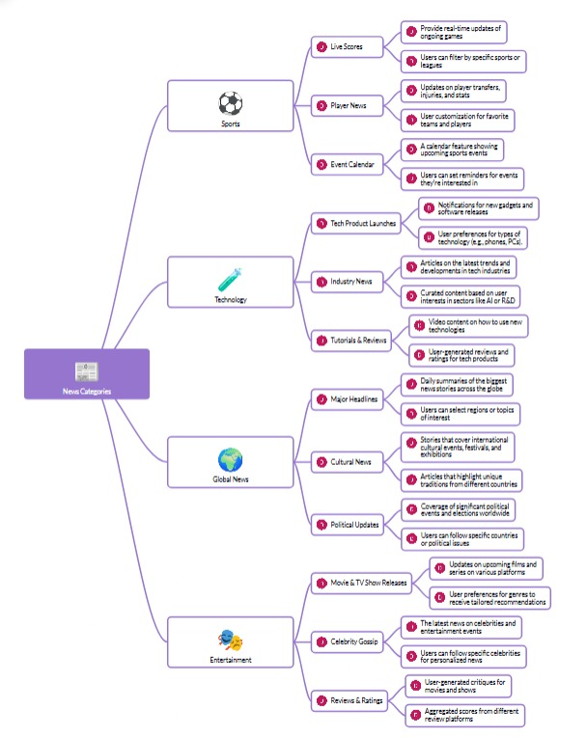

This mind map represents different news categories and their subcategories, showing how information can be personalized and tailored based on user preferences. It divides news into four major sections:

**Sports**

* Live Scores
* Player News
* Event Calendar

**Technology**

* Tech Product Launches
* Industry News (latest trends and developments)
* Tutorials & Reviews

**Global News**

* Major Headlines (daily summaries of significant events)
* Cultural News
* Political Updates (coverage of elections, policies, and world affairs)

**Entertainment**

* Movie & TV Show Releases (updates on new films and shows)
* Celebrity Gossip
* Reviews & Ratings

Apart from this we have to add some of the categories Like Science, Space, Business etc... But mainly we are discussed about these 4 categories.

**Science**

* New inventions
* Latest updates
* Researching about the Future

**Business**

* Latest Start-ups and their Vision
* Forbes updates